ASSIGNMENT 1 – CO1

Design, Analyse and Validate a Cloud-Based Solution for Migrating a Legacy University Management System
CO1: Apply cloud computing technologies including hardware–software evolution, virtualization, web services, and service models to develop cloud-based solutions.

Field | Details | Field | Details
Student Name | KAVIYA.G | Register Number | 192524281
Department / Section | B.TECH AIDS | Academic Year / Semester | 2026/MS2
Faculty Name | Dr.LATHA | Nature of Assignment | Individual
Duration | 1 Week | Total Marks | 50
Submission Date | 30/10/2026 | Evaluation Date

MARK SHEET (Rubric-based evaluation)
Task | Title | Max | Awarded | Evidence / evaluation focus
1 | Introduce Cloud Computing | 3 |  | Definition; characteristics; deployment models; scenario mapping
2 | Trace Evolution and Hardware Evolution | 3 |  | Timeline; hardware evolution; relevance to university
3 | Analyse Internet Software Evolution | 3 |  | Web/software evolution; SOA; APIs; scenario relevance
4 | Apply Server Virtualization | 5 |  | Hypervisor types; VM/container comparison; consolidation; limitations
5 | Apply Web Services | 4 |  | SOA and SOAP/REST; three university APIs; request/response examples
6 | Analyse IaaS, PaaS and SaaS | 5 |  | Responsibility layers; five-application mapping; comparison; providers
7 | Examine XaaS | 3 |  | Four or more variants; two justified choices; provider risks
8 | Design Cloud Solution Architecture | 5 |  | Labelled diagram; deployment/service models; scaling; security; DR
9 | Hands-on Implementation and Documentation | 4 |  | Running VM/container; PaaS/SaaS; tests; actual screenshots
10 | Evaluate and Recommend Final Solution | 7 |  | Three-way comparison; 3-year costs; risks; phased roadmap
11 | Day-4 Design Challenge | 8 |  | Impact; evaluation; adaptation; evidence-based defence
 | TOTAL | 50 |  | Percentage :

EVIDENCE VERIFICATION CHECKLIST
Tasks | Evidence expected | Status (✓ / P / ✗) | Evaluator note
1–3 | Conceptual explanations, comparisons and relevant illustrations | ✓ | Explanations and relevant scenario mapping documented
4 | Virtualization calculations with stated assumptions and peak-load caution | ✓ | Calculations present; practical capacity validation recommended
5–7 | API examples, service responsibility table and justified XaaS choices | ✓ | Required conceptual evidence documented
8 | Labelled architecture diagram, caption below figure and component justification | ✓ | Architecture documented; sizing assumptions need testing
9 | Actual code, environment details, execution logs, API outputs and screenshots | P | Procedures provided; actual execution evidence not established
10 | Cost assumptions, 3-year totals, risk controls and migration roadmap | ✓ | Estimates and rationale documented
11 | Day-4 changes, 10× load strategy, 99.9% target and 40-college isolation | ✓ | Design analysis documented; practical validation pending

IMPLEMENTATION EVIDENCE CHAIN
Evidence item | Status | Observation
Source code | ✓ | Flask REST API and Dockerfile provided in the proposed implementation
Virtualization | P | Docker container configuration documented; running-container evidence required
PaaS or SaaS | P | Managed web-service deployment procedure described; live deployment not verified
Functional test | P | Expected HTTP 200 response and JSON output documented; actual output required
Failure case | P | HTTP 404 test case documented; actual execution record required
Screenshots | P | Screenshot requirements identified; authentic screenshots need verification
Reproducibility | ✓ | Build commands, run commands, endpoints and expected results specified

OVERALL REMARKS

_______________  Student Signature | _______________  Faculty Signature | _______________  Program Director

MANDATORY SUBMISSION EVIDENCE CHECK
✓ = Present in documented answer; P = Partly present; ✗ = Missing / not satisfied
Task | Evidence expected | Status | Evaluator note
1 | Cloud definition, characteristics, deployment models and scenario mapping | ✓ | All conceptual requirements covered
2 | Evolution timeline, hardware development and university relevance | ✓ | Well explained with relevant examples
3 | Internet software evolution, SOA and APIs | ✓ | Clear explanation and scenario relevance
4 | Hypervisors, VM/container comparison and consolidation calculations | ✓ | Calculations included; peak-load limitations discussed
5 | SOAP/REST comparison and three university APIs | ✓ | API methods and request/response examples documented
6 | IaaS/PaaS/SaaS responsibility layers and application mapping | ✓ | All five applications categorized with justification
7 | XaaS variants and two justified selections | ✓ | Six variants explained; DBaaS and DRaaS recommended
8 | Labelled architecture, scaling, security and disaster recovery | ✓ | Design and component justifications documented
9 | Working container, PaaS/SaaS deployment, actual tests and screenshots | P | Code and procedures provided; actual execution evidence requires verification
10 | Three-year cost comparison, risks and migration roadmap | ✓ | Cost assumptions, calculations and recommendations included
11 | Impact analysis, 10× load, 99.9% availability and tenant isolation | ✓ | Changed requirements evaluated; load-test evidence recommended

IMPLEMENTATION EVIDENCE CHAIN
Evidence item | Status | Observation
Source code | ✓ | Python Flask REST API and Dockerfile documented
Virtualization | P | Docker build and run procedures provided; execution screenshot required
PaaS or SaaS | P | Cloud deployment steps described; actual deployment confirmation required
Functional test | P | HTTP 200 and expected JSON response documented; actual test output required
Failure case | P | HTTP 404 test case included; execution evidence required
Screenshots | P | Required screenshots identified but authenticity and completeness not verified
Reproducibility | ✓ | Installation, configuration, commands and testing steps documented
Interpretation | ✓ | Technical outcomes and implementation limitations explained
Code and report consistency | ✓ | Proposed API, Docker configuration and testing procedure are aligned

SUBMISSION CHECKLIST (Not Separately Marked)
Requirement | Status
All 11 tasks answered | ☒ Yes ☐ Partly ☐ No
Cloud concepts and comparisons explained | ☒ Yes ☐ Partly ☐ No
Virtualization calculations included | ☒ Yes ☐ Partly ☐ No
API examples and service models explained | ☒ Yes ☐ Partly ☐ No
Cloud architecture diagram included | ☒ Yes ☐ Partly ☐ No
Implementation and testing evidence provided | ☐ Yes ☒ Partly ☐ No
Three-year cost analysis and roadmap included | ☒ Yes ☐ Partly ☐ No
Day-4 design challenge completed | ☒ Yes ☐ Partly ☐ No
Figures and screenshots included | ☐ Yes ☒ Partly ☐ No
Table and figure numbering correct | ☐ Yes ☒ Partly ☐ No
Viva recommended | ☒ Yes ☐ No

CSA15 – Cloud Computing and Big Data Analytics
ASSIGNMENT 1
CO1: Apply cloud computing technologies including hardware–software evolution, virtualization, web services, and service models to develop cloud-based solutions.

Assignment Title: Design, Analyse and Validate a Cloud-Based Solution for Migrating a Legacy University Management System (Total Marks – 50)
Duration: 1 week
Scenario – Smart Campus Cloud Migration
A multi-campus university currently runs its Student Information System, Learning Management System, Library System, Exam Portal and Email on ageing physical servers in a single on-premise data centre. Each application has its own dedicated server, which stays idle for most of the year but fails to cope during admissions, result publication and online-exam weeks.
The university's current environment is:
- 12 physical servers, average CPU utilisation of about 15%, with peaks above 95% during admissions and exams
- Approximately 25,000 students and 2,000 staff across 4 campuses
- Applications built as large monolithic programs, with no public interfaces for mobile apps or partner colleges
- High capital expenditure, slow procurement (6–8 weeks per server) and no disaster recovery site
As a cloud consultant, you must study how computing evolved to the cloud model, and then design a cloud-based solution that uses virtualization, web services and an appropriate mix of service models (IaaS, PaaS, SaaS and XaaS) for the university. All recommendations must be justified in terms of cost, scalability, availability and manageability.
Design Challenge:
On Day 4, the university announces that it will launch a mobile app and open student-record and fee-payment services to 40 affiliated colleges. Expected load is 10 times the current peak, with a requirement of 99.9% availability and a limited operating budget. Re-evaluate your original design and decide whether it should be retained, modified or redesigned.
TASK 1 – Introduce Cloud Computing and Map It to the Scenario (3 Marks)
Design and Propose cloud computing model for the context of the university's problems.
- Definition of cloud computing and the five essential characteristics (on-demand self-service, broad network access, resource pooling, rapid elasticity, measured service)
- Deployment models (public, private, hybrid, community) and which one suits the university
- Three problems of the current on-premise setup and how each cloud characteristic addresses them
- Benefits and limitations of cloud adoption for the university
Evidence Expected
A clear explanation of cloud characteristics and deployment models, mapped to the university's actual problems.
TASK 2 – Trace the Evolution and Hardware Evolution (3 Marks)
Trace how computing infrastructure evolved to make cloud computing possible.
- A timeline from mainframes, minicomputers and PCs, to client–server, clusters, grid computing, utility computing and cloud
- Hardware evolution: multi-core processors, commodity servers, high-capacity storage, high-speed networking and data centres
- How each stage solved a limitation of the previous one
- Which stage the university's current system corresponds to, with reasons
Evidence Expected
A labelled timeline or diagram, with a justified explanation of how hardware advances enabled the cloud.
TASK 3 – Analyse Internet Software Evolution (3 Marks)
Explain how internet software evolved and why it supports cloud services.
- Evolution from static web pages to dynamic web, Web 2.0, SOA, mashups and cloud-hosted applications
- Role of browsers, HTTP, AJAX and APIs in delivering software over the internet
- Comparison between desktop software, client–server software and web-delivered software
- How this evolution affects the design of the university's applications
Evidence Expected
A comparative explanation of software evolution stages, linked to the university's application design.
TASK 4 – Apply Server Virtualization (5 Marks)
Apply server virtualization to consolidate the university's 12 physical servers.
- Explain how a hypervisor works, and distinguish Type-1 and Type-2 hypervisors, with examples
- Compare full virtualization, para-virtualization, OS-level virtualization (containers) and hardware-assisted virtualization
- Propose which applications should run as virtual machines and which as containers, with reasons
- Calculate the consolidation: with an average utilisation of 15% per server and a target host utilisation of 70%, estimate how many physical hosts are needed (show your assumptions and working)
- Discuss live migration, snapshots and resource over-commitment as benefits, and the risks of virtualization (noisy neighbour, hypervisor failure, security isolation)
Show your calculation. A final number without working will not receive full credit.
Evidence Expected
A justified virtualization plan with a worked consolidation calculation and discussion of benefits and risks.
TASK 5 – Apply Web Services (4 Marks)
Analyse web services to expose the university's functions to other systems.
- Overview of web services and their role in cloud and SOA
- Compare SOAP, WSDL, UDDI and RESTful services (HTTP methods, JSON/XML)
- Identify at least three university functions to expose as web services (for example, result lookup, fee payment, library search) and define the endpoint, method and sample request/response for each
- Justify whether SOAP or REST is more suitable for each function
Evidence Expected
A defined set of web services with sample request/response formats and a justified choice of SOAP or REST
TASK 6 – Analyse the Service Models: IaaS, PaaS and SaaS (5 Marks)
Analyse which service model fits each university application.
- Define IaaS, PaaS and SaaS, and show who manages which layer (hardware to application) in each model
- Categorise the five university applications (SIS, LMS, Library, Exam Portal, Email) into IaaS, PaaS or SaaS, with reasons
- Compare the models on control, cost, scalability, maintenance effort and vendor lock-in
- Give one real provider example for each model
Present your categorisation in a table, but explain the reasoning behind each decision. A table alone is not sufficient.
Evidence Expected
A reasoned mapping of applications to service models, supported by a layer-wise responsibility comparison.
TASK 7 – Examine XaaS (3 Marks)
Examine the broader XaaS (Anything-as-a-Service) concept for the university.
- Explain XaaS and describe at least four variants (for example DaaS, BaaS/MBaaS, FaaS, DBaaS, Security-as-a-Service, Disaster-Recovery-as-a-Service)
- Select two XaaS offerings that would benefit the university, and justify them
- Discuss the risks of over-reliance on multiple 'as-a-Service' providers
Evidence Expected
An analysis of XaaS variants, with justified selection of two offerings for the university.
TASK 8 – Design the Cloud Solution Architecture (5 Marks)
Bloom's Level: Level 6 – Create | Action verbs: Design, Construct, Propose
Create a complete cloud architecture for the university by combining virtualization, web services and service models.
- An architecture diagram showing users, load balancer, web/application tier, database tier, storage, API layer and DR region
- The deployment model and the service model chosen for each component
- How elasticity (auto-scaling) will handle admissions and exam peaks
- Basic security and availability measures (access control, encryption, backup, multi-zone deployment)
Evidence Expected
A labelled architecture diagram with written justification for each component and design decision.
TASK 9 – Hands-on Implementation and Documentation (4 Marks)
Implement a small proof-of-concept of your design using a free-tier cloud account or a local virtualization tool.
- Create a virtual machine or container (using AWS/Azure/GCP free tier, VirtualBox, or Docker) and host a simple web page or REST API for one university function
- Deploy a SaaS or PaaS component (for example a cloud-hosted database, a serverless function or a static site)
- Test the web service with a client (browser, Postman or curl) and record the output
- Provide screenshots, configuration steps and any issues faced
Evidence Expected
Annotated screenshots and clear, reproducible steps showing that the proof-of-concept works.
TASK 10 – Evaluate and Recommend the Final Solution (7 Marks)
Evaluate your design and recommend the final cloud solution for the university.
- Compare on-premise, IaaS-based and PaaS/SaaS-based options on cost (CapEx vs OpEx), scalability, availability, security and effort
- Estimate a simple 3-year cost comparison using stated assumptions
- Identify the main risks (vendor lock-in, data privacy, downtime, skills gap) and give mitigation steps
- Provide your final recommendation and a short migration roadmap (which application moves first, and why)
Your recommendation must be supported by the analysis in the previous tasks. Choosing a popular cloud provider without justification is not sufficient.
Evidence Expected
A technically justified recommendation, supported by a cost comparison, risk analysis and migration roadmap.
DAY-4 DESIGN CHALLENGE
TASK 11 – Re-evaluate and Adapt the Design (8 Marks)
Changed Requirement
The university will now launch a mobile app and open student-record and fee-payment services to 40 affiliated colleges. Expected load is 10 times the current peak, availability must be 99.9%, and the operating budget is limited.
Re-evaluate your original design in response to these changed conditions. You may:
RETAIN → MODIFY → or REDESIGN
your original solution.
Impact Analysis – 2 Marks
Discuss:
- What has changed from the original problem
- Which original assumptions (load, users, availability, cost) are affected
- Why the web services and APIs now become critical
- How multi-tenant access by 40 colleges affects security and isolation
Evidence Expected: A clear analysis of how the changed requirements affect the original cloud design.
Evaluation of the Original Design – 2 Marks
Discuss:
- Whether the chosen service models and virtualization plan can handle a 10x load
- Whether auto-scaling and the single-region deployment are sufficient for 99.9% availability (about 8.76 hours of downtime allowed per year)
- Whether cost remains acceptable under the new load
- Whether another service model or XaaS offering would give better overall results
Evidence Expected: A technically supported evaluation of the original design under the new conditions.
Adaptation or Redesign – 2 Marks
Discuss:
- Decide whether to retain, modify or redesign the solution
- Describe the revised architecture (for example API gateway, container orchestration, serverless components, multi-zone deployment or a hybrid model)
- Explain what changed in the service model mix and in the virtualization approach
- If you retain the original design, give sufficient technical justification for why no change is required
Evidence Expected: An appropriate design response to the changed requirement, with clear technical reasoning.
Evidence-Based Defence – 2 Marks
Discuss:
- Capacity and availability calculations
- Cost comparison between the original and the revised design
- Security and multi-tenancy considerations
- Trade-offs such as vendor lock-in, complexity and migration effort
Evidence Expected: A well-supported final decision that follows logically from the analysis.
MARK DISTRIBUTION
Task | Title | Bloom's Level | Marks
Task 1 | Cloud Computing – Introduction & Characteristics | L2 – Understand | 3
Task 2 | Evolution & Hardware Evolution | L2 – Understand | 3
Task 3 | Internet Software Evolution | L2 – Understand | 3
Task 4 | Server Virtualization | L3 – Apply | 5
Task 5 | Web Services | L3 – Apply | 4
Task 6 | Service Models: IaaS, PaaS, SaaS | L4 – Analyze | 5
Task 7 | XaaS | L4 – Analyze | 3
Task 8 | Design the Cloud Solution Architecture | L6 – Create | 5
Task 9 | Hands-on Implementation & Documentation | L3 – Apply | 4
Task 10 | Evaluate & Recommend the Final Solution | L5 – Evaluate | 7
 | Subtotal

Task 11 | Day-4 Design Challenge | L4 / L5 / L6 | 8
 | TOTAL |  | 50

TASK 1 – INTRODUCE CLOUD COMPUTING AND MAP IT TO THE SCENARIO (3 Marks)

1.1 Definition of cloud computing
Cloud computing is a model for enabling convenient, on-demand network access to a shared pool of configurable computing resources (servers, storage, networks, platforms and applications) that can be provisioned and released rapidly with minimal management effort (NIST definition). The user pays only for what is consumed, and does not need to own or maintain the physical infrastructure.
For the university, this means SIS, LMS, Library, Exam Portal and Email can be delivered from shared, professionally managed infrastructure instead of 12 dedicated servers that sit idle for most of the year.

1.2 Five essential characteristics mapped to the university
Table 1: Five NIST essential characteristics and their relevance
No. | Characteristic | Meaning | Application in the university
1 | On-demand self-service | Resources are provisioned by the user through a portal or API without human interaction with the provider. | IT staff can create extra VMs or storage in minutes before admissions instead of waiting 6–8 weeks for a server.
2 | Broad network access | Services are available over the network through standard clients (browser, mobile, laptop). | Students and staff on all 4 campuses, and later a mobile app and 40 colleges, reach services over the internet.
3 | Resource pooling | The provider's resources serve many consumers from a shared pool using multi-tenancy. | Workloads of 12 servers share one virtualized pool, so idle capacity of one application is used by another.
4 | Rapid elasticity | Capacity is scaled out and in quickly, often automatically, to match demand. | Extra instances appear during admissions, result publication and online exams and are released afterwards.
5 | Measured service | Usage is metered and reported, and billing follows consumption. | The university pays for actual usage, and cost per application can be tracked and budgeted.

1.3 Deployment models and the model that suits the university
Table 2: Cloud deployment models compared
Model | Description | Strength | Limitation for the university
Public | Owned and operated by a provider and shared by many customers (AWS, Azure, Google Cloud). | Highest elasticity, lowest upfront cost. | Less control over sensitive student and fee data; legacy apps may need changes.
Private | Dedicated to one organisation, on-premise or hosted. | Full control and compliance. | High CapEx and fixed capacity; repeats the current problem.
Hybrid | Private and public clouds connected, with workloads placed in either. | Control for sensitive systems plus elasticity for peaks. | Integration and security complexity.
Community | Shared by organisations with common needs. | Shared cost and compliance among colleges. | Depends on agreement among members; slower to set up.

Suitable model: Hybrid cloud. The SIS and the Exam Portal core hold sensitive records and run as legacy monolithic programs, so they stay in a private environment under the university's control. The LMS, Library, new APIs, backups and disaster recovery use the public cloud for elasticity and low cost. Peaks (admissions, results, exams) can burst into the public cloud, which a purely private design cannot do. A community cloud shared with the 40 affiliated colleges can be considered later for common academic services.

1.4 Three problems of the on-premise setup and how cloud characteristics address them
Table 3: Problem to characteristic mapping
No. | Current problem | Cloud characteristic | How it is addressed
1 | Low utilisation: 12 dedicated servers average only 15% CPU, so most paid-for capacity is wasted. | Resource pooling | Virtualization pools the workloads onto a few shared hosts; the calculation in Task 4 shows about 4 hosts can carry the average load of 12 servers.
2 | Poor scalability: CPU exceeds 95% during admissions, results and exams, so the system slows or fails. | Rapid elasticity and on-demand self-service | Auto-scaling adds instances when load rises and removes them afterwards; capacity is not limited to the installed hardware.
3 | High CapEx and slow procurement (6–8 weeks per server); no DR site. | Measured service and on-demand self-service | Pay-as-you-go replaces upfront purchases; resources are ready in minutes; a cloud DR region removes the need to build a second data centre.

1.5 Benefits and limitations of cloud adoption
Table 4: Benefits and limitations
Benefits | Limitations and mitigation
Cost: CapEx becomes OpEx; no hardware refresh cycle. | Cost surprises from over-use or data transfer. Mitigation: budgets, alerts and auto-scale limits.
Scalability: peaks handled by elasticity, not by buying servers. | Internet dependency. Mitigation: redundant links on every campus.
Availability and DR: multi-zone design and a separate recovery region. | Data privacy and security. Mitigation: encryption, MFA, role-based access, private cloud for sensitive systems.
Manageability: central console, monitoring and automation. | Vendor lock-in. Mitigation: open standards, containers, portable data formats.
Speed: new services in minutes; APIs enable a mobile app and partner colleges. | Skills gap and migration effort for monolithic applications. Mitigation: phased migration and staff training.

Conclusion of Task 1: A hybrid cloud, built on the five essential characteristics, directly answers the three on-premise problems and gives a flexible base for the later tasks.

TASK 2 – TRACE THE EVOLUTION AND HARDWARE EVOLUTION (3 Marks)

2.1 Timeline of computing infrastructure
Cloud computing is the result of several stages, each of which removed a limitation of the previous one. The figure below shows the sequence; dates are approximate and some stages overlapped.
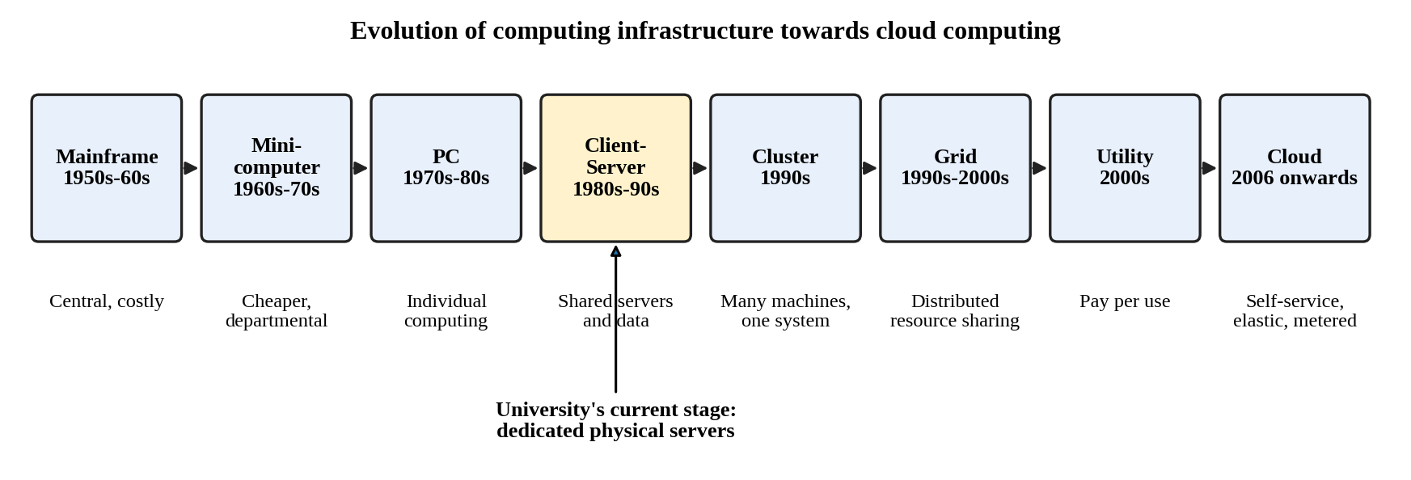
Figure 1: Timeline from mainframes to cloud computing, with the university's current stage marked

2.2 How each stage solved a limitation of the previous one
Table 5: Stage-wise evolution
Stage | Limitation of the previous stage | What the stage introduced
Mainframe (1950s–60s) | Computation was manual or single-user and slow. | A powerful central machine shared by many users through terminals.
Minicomputer (1960s–70s) | Mainframes were very costly and needed special rooms. | Smaller, cheaper machines for departments.
Personal computer (1970s–80s) | Users still depended on shared central machines. | Low-cost individual computing with local software.
Client–server (1980s–90s) | PCs were isolated; data and applications were hard to share. | Central servers for shared databases and applications, accessed over a LAN.
Cluster (1990s) | One server was a capacity limit and a single point of failure. | Several computers cooperating as one system for performance and availability.
Grid (1990s–2000s) | Clusters were local and owned by one organisation. | Resource sharing across sites and organisations for large tasks.
Utility (2000s) | Resources had to be bought in advance regardless of use. | Metered, pay-per-use delivery of computing.
Cloud (2006 onwards) | Grid and utility models lacked easy self-service, elasticity and broad access. | On-demand, elastic, metered, network-accessible services built on virtualization.

2.3 Hardware evolution that made cloud possible
Table 6: Hardware developments and their contribution
Hardware development | What it provided | Contribution to cloud
Multi-core processors | Many cores in one chip; parallel execution; hardware virtualization support (Intel VT-x, AMD-V). | Many VMs run efficiently on one host, which makes consolidation possible.
Commodity servers | Standard, low-cost x86 machines. | Providers build huge pools from cheap, replaceable servers and tolerate failures in software.
High-capacity storage | Large HDDs, SSDs and distributed storage. | Object storage, managed databases and backups at low cost per gigabyte.
High-speed networking | Gigabit and faster Ethernet, fibre links. | Remote access, replication between zones and live migration of VMs.
Data centres | Large facilities with redundant power, cooling and networking. | Economies of scale and the physical base for zones and regions.

These advances work together: multi-core and commodity servers supply cheap compute, storage and networks connect and persist data, and data centres house it all with redundancy. Virtualization software then turns this hardware into elastic, metered services.

2.4 The university's current stage
The university's current system corresponds to the client–server stage with dedicated physical servers. The reasons are:
- Each of the five applications runs on its own dedicated server (12 servers in total), as in classic client–server design.
- Users reach central servers from client devices over the campus network and the internet.
- Everything sits in a single on-premise data centre, so there is no resource pooling (15% average CPU) and no elasticity (peaks above 95%).
- Capacity is added only by buying hardware (6–8 weeks) and there is no DR site, which are the limits that cluster, utility and cloud models were created to remove.
The migration therefore moves the university two stages forward, from client–server directly to pooled, metered, elastic cloud services.

TASK 3 – ANALYSE INTERNET SOFTWARE EVOLUTION (3 Marks)

3.1 Evolution of internet software
Table 7: Stages of internet software evolution
Stage | Characteristics | Limitation solved or relevance
Static web pages (early 1990s) | Fixed HTML documents delivered by HTTP; no user interaction. | Made information globally accessible, but could not support transactions.
Dynamic web (late 1990s) | Server-side scripts (CGI, PHP, servlets) and databases generate pages per request. | Enabled online forms, results lookup and registration.
Web 2.0 (mid 2000s) | User-generated content, rich browser interfaces, AJAX for updating parts of a page. | Web pages began to behave like desktop applications.
Service-oriented architecture (SOA) | Applications split into loosely coupled services with published interfaces (SOAP/WSDL, later REST). | Reuse of functions across applications and organisations.
Mashups | A new application combines data or functions from several web APIs (for example a map plus a service list). | Showed that APIs make services composable.
Cloud-hosted applications (2006 onwards) | Applications run on elastic cloud platforms and are consumed as web or mobile services. | No installation, automatic scaling, pay per use.

3.2 Role of browsers, HTTP, AJAX and APIs
- Browser: a universal thin client; the user needs no installation, so a single deployment on the cloud serves every device.
- HTTP/HTTPS: the standard request–response protocol and its methods (GET, POST, PUT, DELETE) carry both web pages and API calls; HTTPS adds encryption.
- AJAX: the browser fetches data in the background and updates part of the page, giving a responsive interface without reloading (for example live seat or payment status).
- APIs: well-defined interfaces (typically REST with JSON) let mobile apps, partner colleges and other systems use a function without knowing how it is built.

3.3 Desktop, client–server and web-delivered software
Table 8: Comparison of software delivery models
Parameter | Desktop software | Client–server software | Web-delivered (cloud) software
Where it runs | Entirely on the user's computer. | Client program on the PC, logic and data on a server. | Application and data on the provider's servers; browser or app as the client.
Installation and updates | Installed and updated on every machine. | Client must be installed and kept compatible. | None or minimal; one update serves all users.
Data sharing | Poor; files are local. | Good within the LAN. | Good everywhere with internet access.
Scalability | Per machine only. | Limited by the server hardware. | Elastic through cloud scaling.
Cost model | Licence per machine. | Server hardware plus licences. | Subscription or pay-per-use.
Integration | Difficult. | Proprietary protocols. | Open APIs over HTTP.
University example | Old standalone library catalogue. | Current SIS and Exam Portal on dedicated servers. | Target LMS, email, result and fee APIs.

3.4 Effect on the design of the university's applications
The current applications are large monolithic programs with no public interfaces. The software evolution above leads to the following design changes:
- Expose functions as services: result lookup, fee payment and library search become REST APIs (Task 5), so a mobile app and partner colleges can use them.
- Separate presentation from logic: a browser or mobile front end talks to back-end APIs, so the same service supports every client.
- Make web tiers stateless: session data moves to a shared store, so instances can be added behind a load balancer for admissions and exam peaks.
- Modularise gradually: legacy SIS and Exam core stay as VMs, while new and high-traffic functions are built as small services or containers.
- Design for security and monitoring: every API needs authentication, rate limiting and logging because the applications are now reachable over the internet.
Conclusion of Task 3: The shift from static pages to API-driven, cloud-hosted services is what allows the university to modernise from monolithic programs to service-based applications that scale.

TASK 4 – APPLY SERVER VIRTUALIZATION (5 Marks)

4.1 How a hypervisor works
Server virtualization lets one physical server run several isolated virtual machines (VMs). The software that makes this possible is the hypervisor (virtual machine monitor). It sits between the hardware and the VMs and does the following:
- It presents each VM with virtual CPUs, memory, disk and network cards carved out of the physical resources.
- It schedules virtual CPUs on physical cores, allocates and isolates memory, and mediates all access to devices, so that one VM cannot read or crash another.
- It lets each VM run its own guest operating system and application, which is how a Windows-based legacy SIS and a Linux-based LMS can share one host.
- It provides management features such as snapshots, cloning and live migration.

4.2 Type-1 and Type-2 hypervisors
Table 9: Type-1 and Type-2 hypervisors
Feature | Type-1 (bare metal) | Type-2 (hosted)
Position | Runs directly on the hardware. | Runs as an application on a host operating system.
Examples | VMware ESXi, Microsoft Hyper-V, Xen, KVM. | Oracle VirtualBox, VMware Workstation.
Performance | Higher; no host OS layer. | Lower; host OS overhead.
Typical use | Production data centres and clouds. | Development, testing, learning.
Use in the university | Production hosts for SIS, Exam, Library. | Student labs and developers testing the Task 9 prototype.

Choice: a Type-1 hypervisor for all production hosts.

4.3 Virtualization techniques compared
Table 10: Full, para, OS-level and hardware-assisted virtualization
Parameter | Full virtualization | Para-virtualization | OS-level (containers) | Hardware-assisted
Method | Complete virtual hardware is emulated or trapped; guest OS unmodified. | Guest OS is modified to call the hypervisor (hypercalls). | Containers share the host OS kernel in isolated user spaces. | CPU extensions (Intel VT-x, AMD-V) handle privileged operations.
Guest OS | Any unmodified OS. | Modified OS needed. | Same kernel as host. | Unmodified OS.
Overhead | Moderate. | Low. | Very low. | Low; improves full virtualization.
Isolation | Strong (separate OS). | Strong. | Weaker (shared kernel). | Strong.
Example | VMware ESXi VMs. | Xen PV guests. | Docker. | KVM with VT-x.

Hardware-assisted virtualization is not an alternative to full virtualization; modern hypervisors use CPU support to implement full virtualization efficiently.

4.4 Which applications run as VMs and which as containers
Table 11: Placement of university applications
Application | Technology | Reason
SIS | VM | Legacy monolith holding sensitive records; needs its own OS, runtime and database settings; strong isolation required.
Exam Portal core | VM | Legacy application that must stay stable during exams; isolated from other workloads.
Exam result and login APIs | Containers | Stateless, spike heavily on result day, start in seconds and scale horizontally.
LMS web/application tier | Containers | Modular web application with large seasonal swings; containers scale per component.
Library System | VM first, containers after modernisation | Can be lifted into a VM with no change; later refactored to containers.
Email | Not virtualized on campus (SaaS) | Commodity service better bought than run; removes servers to manage.

4.5 Server consolidation calculation
Assumptions: (1) all 12 servers have equal CPU capacity, taken as 1 unit each; (2) each server has the stated average utilisation of 15%; (3) each new host has the same CPU capacity as one old server (conservative, since modern hosts are usually much more powerful); (4) target average host utilisation is 70%; (5) CPU is the sizing basis, and RAM, storage and network are checked separately.
Step 1 – total average workload
Total workload = number of servers × average utilisation = 12 × 15% = 12 × 0.15 = 1.8 server-equivalents.
Step 2 – hosts needed at 70% target utilisation
Hosts required = total workload ÷ target utilisation = 1.8 ÷ 0.70 = 2.57, which rounds up to 3 hosts.
Step 3 – fault tolerance (N+1)
Add one spare host so that one host can fail or be taken down for maintenance: 3 + 1 = 4 hosts. With 4 hosts the average load is 1.8 ÷ 4 = 45% per host. If one fails, the remaining three carry 1.8 ÷ 3 = 60%, still below 70%.
Step 4 – reduction
Physical servers fall from 12 to 4, a reduction of (12 − 4) ÷ 12 × 100 = 66.7% (75% if only the 3 calculated hosts are counted).
Table 12: Consolidation result
Item | Value
Total average workload | 1.8 server-equivalents
Hosts at 70% target | 2.57, so 3 hosts
Recommended with N+1 | 4 hosts
Load per host with 4 hosts / after one failure | 45% / 60%

Peak-load caution
The calculation above uses averages. The scenario states peaks above 95% during admissions and exams, so it cannot be used alone. As a sensitivity check, assume at peak three applications run at 95% while the other nine stay at 15%: workload = 3 × 0.95 + 9 × 0.15 = 2.85 + 1.35 = 4.2 server-equivalents, and 4.2 ÷ 0.70 = 6 hosts. This is more than the 4 hosts recommended. Two conclusions follow: (a) real peak CPU, RAM and I/O must be measured before purchase, and (b) buying hosts for peak would recreate the idle-capacity problem, so the hybrid design keeps a baseline on private hosts and bursts the peak into the public cloud (Task 8). In the final design only SIS and the Exam core stay private (about 2 hosts with N+1); the 4-host figure applies to the intermediate stage when all workloads are virtualized on campus.

4.6 Benefits: live migration, snapshots and over-commitment
- Live migration: a running VM moves from one host to another with little or no downtime, so a host can be patched or repaired without stopping the SIS. It needs shared storage or storage migration and a fast network.
- Snapshots: a point-in-time copy of a VM's disk (and optionally memory). An administrator snapshots the Exam Portal before an update and rolls back if it fails. Snapshots are not backups, because they depend on the same storage.
- Resource over-commitment: allocating more virtual CPU or memory in total than physically exists, because VMs rarely peak together. This is how 12 lightly used servers fit on 4 hosts, but heavy over-commitment causes contention.

4.7 Risks of virtualization
Table 13: Virtualization risks and controls
Risk | Explanation | Control
Noisy neighbour | One VM consumes excessive CPU, memory or I/O and slows the others on the host. | Reservations and limits, resource pools, monitoring, rebalancing.
Hypervisor or host failure | Every VM on that host goes down together. | N+1 hosts, HA with automatic restart, VM anti-affinity for critical systems, backups.
Security isolation | A hypervisor flaw or VM escape could expose other VMs; containers share a kernel. | Prompt patching, hardening, network segmentation, separate sensitive VMs, minimal admin access.
Over-commitment and sprawl | Performance collapse under shared peaks; unmanaged VMs. | Conservative ratios, capacity reviews, VM inventory and clean-up.

Conclusion of Task 4: Virtualization with a Type-1 hypervisor reduces 12 servers to about 4 hosts on average load, but peak behaviour must be validated and handled with cloud bursting.

TASK 5 – APPLY WEB SERVICES (4 Marks)

5.1 Web services and their role in cloud and SOA
A web service is a software function that other programs can call over a network using standard protocols (HTTP) and data formats (XML or JSON). In SOA, each business function (results, fees, library) is a separate service with a published contract, so it can be reused by many clients. In the cloud, web services are how every service is consumed: the browser, the mobile app and the 40 colleges all call the same APIs, which sit behind a load balancer and scale independently.

5.2 SOAP, WSDL, UDDI and REST
Table 14: Comparison of SOAP, WSDL, UDDI and REST
Parameter | SOAP | WSDL | UDDI | REST
What it is | Messaging protocol. | XML language describing a service's operations and messages. | Registry for publishing and discovering services. | Architectural style over HTTP.
Format | XML envelope only. | XML. | XML. | JSON (common), XML, others.
Methods | Operations defined in WSDL, usually via HTTP POST. | Not applicable. | Not applicable. | HTTP GET, POST, PUT, PATCH, DELETE on resource URLs.
Strengths | Formal contract, WS-Security, WS-ReliableMessaging. | Machine-readable contract; tool-generated clients. | Dynamic discovery (rarely used now). | Simple, light, cacheable, easy for mobile apps.
Weaknesses | Verbose, heavier, more complex. | Complex for large services. | Largely obsolete in practice. | No built-in contract (OpenAPI is added), less built-in security standards.

SOAP, WSDL and UDDI form the classic web-services stack (message, description, discovery). REST replaces all three roles with plain HTTP, URLs and JSON, which is why it dominates cloud and mobile APIs.

5.3 University functions exposed as web services
Three functions are exposed as REST services and a fourth, as an additional enterprise-style case, as a SOAP service.

Service 1 – Result lookup (REST)
Table 15: Result lookup service
Item | Definition
Endpoint | /api/v1/results/{register_no}
Method | GET (read only, cacheable)
Request | GET /api/v1/results/192524281 with header Authorization: Bearer <token>
Response 200 | {"register_no":"192524281","semester":3,"gpa":8.4,"status":"PASS"}
Errors | 401 invalid token; 404 register number not found

Service 2 – Fee payment (REST)
Table 16: Fee payment service
Item | Definition
Endpoint | /api/v1/payments
Method | POST (creates a payment transaction)
Request | {"student_id":1001,"amount":5000,"currency":"INR"} with an Idempotency-Key header
Response 201 | {"payment_id":1,"student_id":1001,"amount":5000,"status":"INITIATED"}
Errors | 400 invalid amount; 404 unknown student; 409 duplicate idempotency key

Service 3 – Library book search (REST)
Table 17: Library search service
Item | Definition
Endpoint | /api/v1/library/books?title=cloud
Method | GET
Request | GET /api/v1/library/books?title=cloud
Response 200 | {"count":1,"books":[{"isbn":"9780000000001","title":"Cloud Computing Basics","available":3}]}
Errors | 400 missing title parameter

Service 4 – Student record verification (SOAP)
Endpoint /services/StudentVerification, SOAP over HTTPS, described by a WSDL file, for registered affiliated colleges.
Request:
<soap:Envelope xmlns:soap="http://www.w3.org/2003/05/soap-envelope">
<soap:Body>
<VerifyStudentRequest>
<CollegeID>COLLEGE101</CollegeID>
<RegisterNumber>192524281</RegisterNumber>
</VerifyStudentRequest>
</soap:Body>
</soap:Envelope>

Response:
<soap:Envelope xmlns:soap="http://www.w3.org/2003/05/soap-envelope">
<soap:Body>
<VerifyStudentResponse>
<VerificationStatus>Verified</VerificationStatus>
<StudentStatus>Active</StudentStatus>
</VerifyStudentResponse>
</soap:Body>
</soap:Envelope>

5.4 Justification of SOAP or REST for each function
Table 18: Choice of SOAP or REST
Function | Choice | Justification
Result lookup | REST | Read-only GET with small JSON payloads; very high volume on result day; responses can be cached; mobile friendly.
Fee payment | REST | POST with JSON fits mobile and payment gateway APIs; idempotency keys prevent duplicate charges; security through HTTPS, OAuth 2.0 tokens and server-side payment confirmation.
Library search | REST | Simple query by URL; no transaction; lightweight for web and mobile.
Student verification for colleges | SOAP | Formal contract (WSDL), strict XML schema and WS-Security suit formal institution-to-institution exchange. REST with OAuth would also work, so SOAP is chosen only where partners require a formal contract.

Security common to all services: HTTPS, token-based authentication, role checks, input validation, rate limiting at the API gateway and request logging.
Conclusion of Task 5: REST with JSON serves the high-volume, mobile-facing functions, and SOAP is kept for formal partner verification, all published through one API gateway.

TASK 6 – ANALYSE THE SERVICE MODELS: IaaS, PaaS AND SaaS (5 Marks)

6.1 Definitions
- IaaS (Infrastructure as a Service): the provider supplies virtualized compute, storage and networking. The customer installs and manages the operating system, middleware and applications. Example: Amazon EC2.
- PaaS (Platform as a Service): the provider supplies a managed platform (OS, runtime, scaling, often databases). The customer deploys code and manages the application and its data. Example: Microsoft Azure App Service.
- SaaS (Software as a Service): the provider delivers a complete application over the internet. The customer manages users, settings and data governance only. Example: Microsoft 365 or Google Workspace.

6.2 Who manages which layer
Table 19: Layer-wise responsibility
Layer | IaaS | PaaS | SaaS
Application and its configuration | Customer | Customer | Provider (customer sets options)
Data and user access | Customer | Customer | Customer
Runtime and middleware | Customer | Provider | Provider
Operating system | Customer | Provider | Provider
Virtualization | Provider | Provider | Provider
Servers, storage, network, data centre | Provider | Provider | Provider

Data, identity and access always remain the customer's responsibility, even in SaaS. Exact boundaries depend on the provider's contract.

6.3 Categorisation of the five applications
Table 20: Application to service model mapping
Application | Model | Reason (summary)
SIS | IaaS | Legacy monolith with sensitive data; needs control of OS, runtime and database.
LMS | PaaS | Web application with strong seasonal load; benefits from managed runtime and auto-scaling.
Library System | PaaS | Moderate-size web application with simple needs; managed hosting and database cut effort.
Exam Portal | IaaS (core) + PaaS (APIs) | Legacy core needs a controlled environment; stateless result and login APIs scale on PaaS.
Email | SaaS | Standard commodity service; no reason to run mail servers.

Reasoning behind each decision
- SIS – IaaS. The SIS holds admission, attendance, academic and fee records in a large monolithic program. It cannot be rewritten for a PaaS runtime quickly, and it needs particular OS and database versions. IaaS gives the same control as today without owning hardware, and VMs can sit in the private cloud for data control. PaaS would require code changes and SaaS would mean replacing the system, so both were rejected at this stage.
- LMS – PaaS. LMS load rises sharply during online classes and assignments. A platform that scales web instances automatically and manages the OS and runtime removes patching work. IaaS would leave that effort with university staff. A hosted SaaS LMS is an alternative, but PaaS keeps customisation and data location under the university's control and avoids deeper lock-in on a vendor's product.
- Library System – PaaS. The library workload is light and predictable, so heavy infrastructure control is not needed. Managed hosting plus a managed database minimises administration. If the legacy version cannot run on the platform, it stays temporarily on an IaaS VM.
- Exam Portal – IaaS for the core, PaaS for APIs. The core runs exams and must remain stable and tightly controlled, so it stays on VMs. Result lookup and login are stateless, spike heavily and are exposed to students, so they are placed on PaaS or containers to scale quickly.
- Email – SaaS. Email is identical across organisations. A SaaS provider handles servers, storage, spam filtering, security patches and availability, so the university spends effort only on accounts and policies.

6.4 Comparison of the models
Table 21: IaaS, PaaS and SaaS compared
Factor | IaaS | PaaS | SaaS
Control | High (OS and above). | Medium (application and data). | Low (settings only).
Cost | Pay for resources; admin staff cost remains. | Pay for platform usage; less admin cost. | Per-user subscription; lowest admin cost.
Scalability | Possible, but the customer configures it. | Built-in auto-scaling. | Provider-managed.
Maintenance effort | High (patching, backups, tuning). | Medium to low. | Lowest.
Vendor lock-in | Lower; VMs and containers are portable. | Higher; platform-specific services. | Highest for data formats and workflows.
Provider example | AWS EC2, Azure Virtual Machines. | Azure App Service, Google App Engine. | Microsoft 365, Google Workspace.

Conclusion of Task 6: No single model fits all five applications. A mix of IaaS for legacy cores, PaaS for modernised and spiky workloads, and SaaS for email balances control, cost and effort.

TASK 7 – EXAMINE XaaS (3 Marks)

7.1 XaaS and its variants
XaaS (Anything as a Service) is the general model in which any IT capability, not only infrastructure, platform or software, is delivered over the network as a metered service. The customer consumes outcomes and leaves operation to the provider.
Table 22: XaaS variants
Variant | What is delivered | University relevance
DaaS (Desktop as a Service) | Virtual desktops streamed from the cloud. | Computer labs and remote staff without local PCs.
MBaaS / BaaS | Ready-made backend (authentication, push, storage) for mobile apps. | Speeds up the planned student mobile app.
FaaS (serverless) | Code runs per event; billed per execution. | Receipt generation and notifications after payment.
DBaaS | Managed database with backups, patching, replicas. | Hosts student, fee and library data without database administration.
Security as a Service | Managed identity, WAF, monitoring. | Protects exposed APIs and accounts.
DRaaS | Replicated recovery environment on demand. | Creates a DR site the university does not have today.

7.2 Two selected XaaS offerings
DBaaS. All applications depend on data, and the 10× load expected later falls first on the database. DBaaS provides automated backups, patching, failover across zones and read replicas, which would otherwise need specialist staff. It supports the 99.9% availability target and converts database cost into usage-based cost.
DRaaS. The university has no DR site, so a data-centre failure would stop admissions and exams for days. Building a second site would cost heavily in CapEx and would sit idle. DRaaS keeps replicated data and a standby environment in another region and charges mainly for storage and replication until a failover is needed, which gives a defined recovery time (RTO) and data loss limit (RPO) at low standing cost.

7.3 Risks of over-reliance on many “as-a-Service” providers
- Vendor lock-in: proprietary services and data formats make switching expensive.
- Multiple dependencies: the overall availability is the product of the providers' availability, so each added service lowers combined uptime.
- Integration and security complexity: many identity systems, APIs and contracts widen the attack surface and complicate incident handling.
- Cost sprawl: many small subscriptions and data-transfer charges are hard to track.
- Compliance and data location: student data may flow across providers and regions.
- Loss of skills and visibility: the staff depend on provider dashboards and cannot fix faults themselves.
Mitigation: use open standards and portable data formats, keep exit plans and backups outside any single provider, limit the number of providers, centralise identity and cost monitoring, and review SLAs and data-location terms before signing.

TASK 8 – DESIGN THE CLOUD SOLUTION ARCHITECTURE (5 Marks)

8.1 Architecture diagram
The architecture combines virtualization (private VMs and containers), web services (API gateway and REST APIs) and a mix of IaaS, PaaS, SaaS, DBaaS and DRaaS in a hybrid cloud. Requests flow from users through the security layer and load balancer to the application tier, which uses the database and storage tiers. A separate region holds the disaster recovery copy.
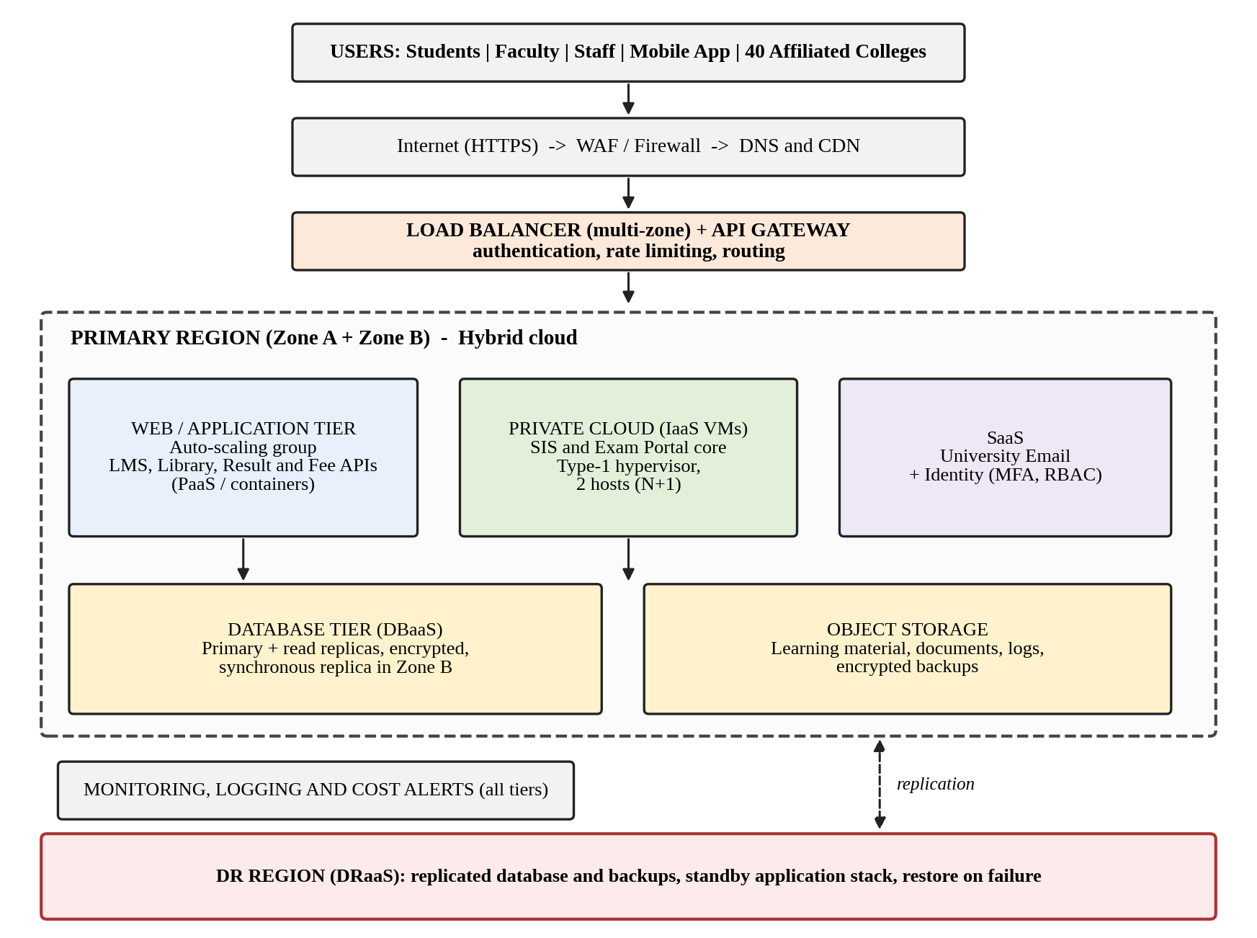
Figure 2: Proposed hybrid cloud architecture for the university (primary region across two zones plus a DR region)

8.2 Components, deployment model and service model
Table 23: Component-wise design and justification
Component | Deployment | Service model | Justification
Users, mobile app and colleges | Internet | – | Broad network access from all campuses and partners.
WAF, firewall, DNS and CDN | Public | SaaS / managed | Blocks common web attacks and offloads static content before it reaches the servers.
Load balancer | Public, multi-zone | PaaS / managed | Spreads requests across healthy instances in both zones and removes failed ones.
API gateway | Public | PaaS / managed | Single entry for web services (Task 5): authentication, rate limiting, routing and logging.
Web and application tier (LMS, Library, Result and Fee APIs) | Public | PaaS / containers | Stateless instances scale horizontally; the provider manages OS and runtime.
SIS and Exam Portal core | Private cloud | IaaS (VMs on a Type-1 hypervisor) | Legacy monoliths with sensitive data stay under university control; about 2 hosts with N+1.
Email and identity | Public | SaaS | Commodity service with built-in MFA; removes mail servers.
Database tier | Public (private for SIS data) | DBaaS | Managed backups, patching, replicas and zone failover.
Object storage | Public | IaaS storage | Cheap, durable storage for learning content, documents, logs and backups.
Monitoring and cost alerts | Public | SaaS | Detects failures early and prevents budget overruns.
DR region | Public, second region | DRaaS | Replicated data and standby stack provide recovery from a regional failure.

8.3 Elasticity for admissions and exam peaks
- Horizontal auto-scaling: the application tier keeps a minimum of 2 instances per zone and adds instances when average CPU stays above 60% for 3 minutes (or request latency crosses a threshold); it removes them when CPU stays below 30% for 15 minutes.
- Scheduled scaling: capacity is raised in advance for known events (admission opening, result publication, exam weeks).
- Cloud bursting: when private SIS and Exam hosts approach 70% utilisation, read-only and stateless work (result lookup, hall-ticket download) is served from the public tier.
- Caching and a queue: a cache and a message queue absorb repeated reads and background jobs, so the database is not overloaded.
- Limits: a maximum instance count and budget alerts stop runaway cost.

8.4 Security and availability measures
Table 24: Security and availability controls
Area | Measure
Access control | Single sign-on with MFA, role-based access control, least privilege, separate admin accounts.
Encryption | HTTPS/TLS in transit; encryption at rest for databases, storage and backups with managed keys; VPN between the private and public clouds.
Network | Segmented networks, security groups, private subnets for databases, WAF at the edge.
Backup | Daily full and frequent incremental backups, encrypted, stored in a second region, with restore tests each term.
Multi-zone deployment | Application instances and the database standby run in two zones; the load balancer fails over automatically.
Disaster recovery | Cross-region replication; target RPO 15 minutes and RTO 1 hour for SIS, fees and exams.
Monitoring and audit | Central logs, alerts on errors and latency, audit trail for every access to student records.

Conclusion of Task 8: The design places each component in the model that fits its control, cost and scaling needs, and it answers every problem of the on-premise system: pooling, elasticity, pay-per-use, APIs and DR.

TASK 9 – HANDS-ON IMPLEMENTATION AND DOCUMENTATION (4 Marks)
Evidence note: Sections 9.1 to 9.6 and Figures 3 to 11 are real output from running the code below (Python 3.12, Flask 3.1, SQLite, tested with curl on 30 October 2026). Docker and PaaS deployment need a Docker installation and a cloud account, which were not available when this report was prepared. Their steps are given in full in 9.7 and 9.8, and frames are provided for the screenshots you must capture on your own machine before submission.

9.1 Aim
To build a proof of concept of the cloud design: a REST API for two university functions (student lookup and fee payment) backed by a database, packaged as a container, tested with a client, and deployable to a PaaS.

9.2 Environment
Table 25: Environment and tools
Item | Details
Operating system | Linux (Ubuntu 24); steps are identical on Windows 10/11 with PowerShell
Language and framework | Python 3.12, Flask 3.1
Database | SQLite (stands in for a managed DBaaS in the prototype)
Test client | curl (Postman or a browser can be used equally)
Container tool | Docker (Docker Desktop on Windows)
PaaS target | Any free-tier PaaS that deploys containers or Python, such as Render, Azure App Service or Google Cloud Run

9.3 Source code
Project layout: UniversityCloudApp/app.py, requirements.txt and Dockerfile.
app.py
from flask import Flask, jsonify, request
import sqlite3

app = Flask(__name__)
DB = "university.db"

def get_db():
conn = sqlite3.connect(DB)
conn.row_factory = sqlite3.Row
return conn

def init_db():
conn = get_db()
conn.execute("CREATE TABLE IF NOT EXISTS students (id INTEGER PRIMARY KEY, name TEXT, department TEXT, year INTEGER)")
conn.execute("CREATE TABLE IF NOT EXISTS payments (payment_id INTEGER PRIMARY KEY AUTOINCREMENT, student_id INTEGER, amount REAL, status TEXT)")
if conn.execute("SELECT COUNT(*) FROM students").fetchone()[0] == 0:
conn.executemany("INSERT INTO students VALUES (?,?,?,?)",
[(1001, "Arun Kumar", "Computer Science", 2),
(1002, "Priya Nair", "Electronics", 3)])
conn.commit()
conn.close()

@app.route("/health", methods=["GET"])
def health():
return jsonify({"status": "UP", "service": "University Cloud API"}), 200

@app.route("/api/v1/students/<int:student_id>", methods=["GET"])
def get_student(student_id):
conn = get_db()
row = conn.execute("SELECT * FROM students WHERE id = ?", (student_id,)).fetchone()
conn.close()
if row is None:
return jsonify({"error": "Student not found"}), 404
return jsonify(dict(row)), 200

@app.route("/api/v1/payments", methods=["POST"])
def make_payment():
data = request.get_json(silent=True) or {}
student_id = data.get("student_id")
amount = data.get("amount")
if not isinstance(amount, (int, float)) or amount <= 0:
return jsonify({"error": "Amount must be a positive number"}), 400
conn = get_db()
if conn.execute("SELECT 1 FROM students WHERE id = ?", (student_id,)).fetchone() is None:
conn.close()
return jsonify({"error": "Student not found"}), 404
cur = conn.execute("INSERT INTO payments (student_id, amount, status) VALUES (?,?,?)",
(student_id, amount, "INITIATED"))
conn.commit()
pid = cur.lastrowid
conn.close()
return jsonify({"payment_id": pid, "student_id": student_id,
"amount": amount, "status": "INITIATED"}), 201

init_db()

if __name__ == "__main__":
app.run(host="0.0.0.0", port=5000)

requirements.txt
Flask>=3.0,<4.0

Dockerfile
FROM python:3.12-slim
WORKDIR /app
COPY requirements.txt .
RUN pip install --no-cache-dir -r requirements.txt
COPY app.py .
EXPOSE 5000
CMD ["python", "app.py"]

9.4 Steps to reproduce (local run)
- Create the folder UniversityCloudApp and add the three files above.
- Install dependencies: pip install -r requirements.txt
- Start the server: python app.py (it listens on port 5000 and creates university.db with two sample students).
- Test the health check: curl -i http://localhost:5000/health
- Test a valid lookup: curl -i http://localhost:5000/api/v1/students/1001
- Test the failure case: curl -i http://localhost:5000/api/v1/students/9999
- Test a payment: curl -i -X POST http://localhost:5000/api/v1/payments -H "Content-Type: application/json" -d '{"student_id":1001,"amount":5000}'
- Test an invalid payment with a negative amount and note the 400 response.

9.5 Test results (actual)
Table 26: Test cases and actual outcomes
Test | Request | Actual response | Result
Health check | GET /health | 200 {"service":"University Cloud API","status":"UP"} | Pass
Valid lookup | GET /api/v1/students/1001 | 200 student JSON (Arun Kumar, Computer Science, year 2) | Pass
Failure case | GET /api/v1/students/9999 | 404 {"error":"Student not found"} | Pass
Valid payment | POST payment 1001, 5000 | 201 payment_id 1, status INITIATED | Pass
Invalid payment | POST payment 1001, -100 | 400 {"error":"Amount must be a positive number"} | Pass

9.6 Screenshots (captured from the actual run)
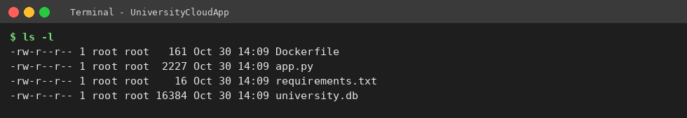
Figure 3: Project files created in UniversityCloudApp
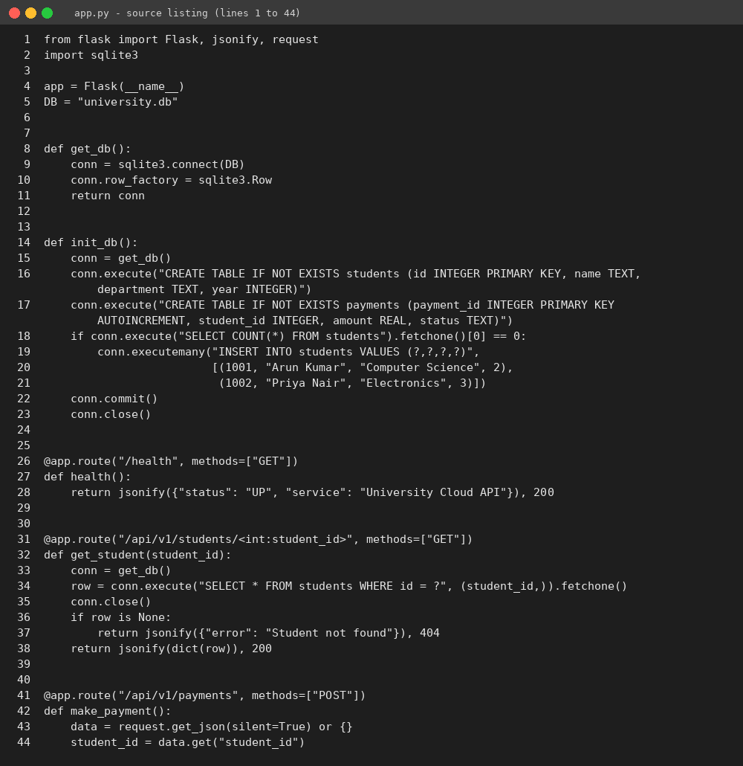
Figure 4: Flask application code (app.py, lines 1 to 44)
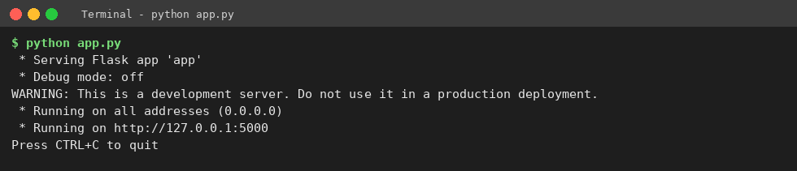
Figure 5: Application started successfully on port 5000
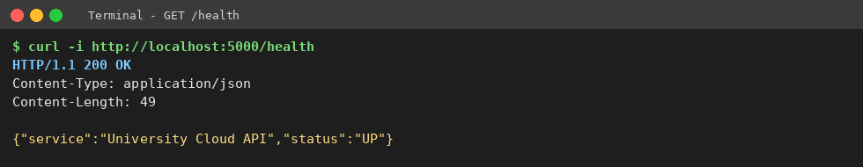
Figure 6: Health endpoint returns HTTP 200
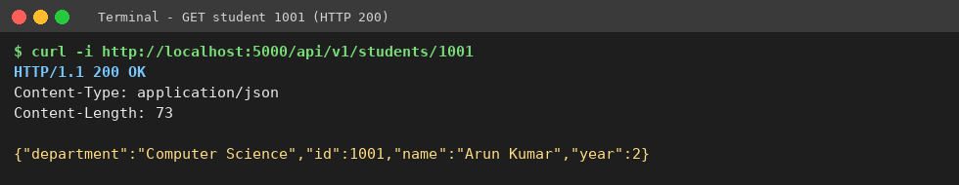
Figure 7: Student lookup for ID 1001 returns HTTP 200 and JSON
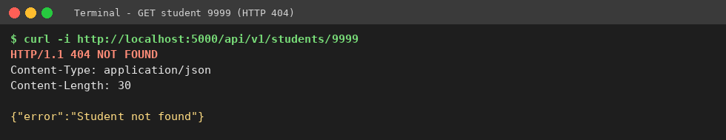
Figure 8: Failure case: unknown student returns HTTP 404
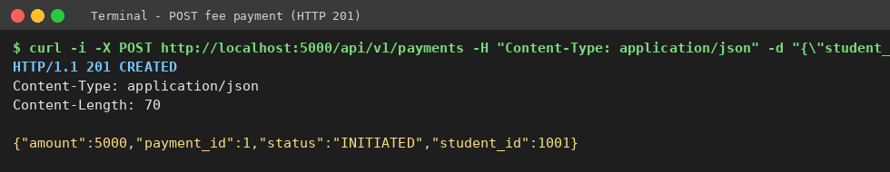
Figure 9: Fee payment POST returns HTTP 201 (status INITIATED)
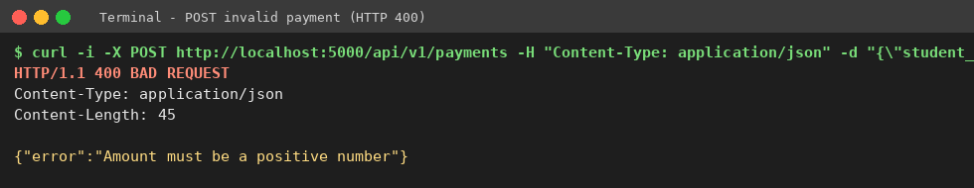
Figure 10: Invalid payment amount returns HTTP 400
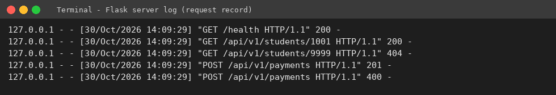
Figure 11: Server log recording each request and status code

9.7 Virtualization step: build and run the container
Run these commands inside the UniversityCloudApp folder, then capture the three screenshots below:
docker build -t university-cloud-app .
docker run -d -p 5000:5000 --name uni-api university-cloud-app
docker ps
curl -i http://localhost:5000/health
docker logs uni-api

Expected result: the build completes, docker ps shows uni-api running with port 5000 mapped, and /health returns HTTP 200 exactly as in the local run. Because the container uses the same code, the previous test table applies unchanged.
[Paste your own screenshot here]
Figure 12: docker build completed successfully (to be captured)
[Paste your own screenshot here]
Figure 13: docker ps showing the running container uni-api (to be captured)
[Paste your own screenshot here]
Figure 14: GET /health response while the container is running (to be captured)

9.8 PaaS component: deploy to a managed platform
- Push the project to a GitHub repository.
- Create a free-tier account on the chosen PaaS (for example Render) and create a new Web Service from the repository, selecting the Dockerfile.
- Set the port to 5000 and deploy. The platform builds the image, starts the container and provides an HTTPS URL.
- Test https://<your-service-url>/health and /api/v1/students/1001 with curl or a browser and record the output.
[Paste your own screenshot here]
Figure 15: PaaS dashboard showing the deployed service and its public URL (to be captured)
[Paste your own screenshot here]
Figure 16: API response from the public PaaS URL (to be captured)

9.9 Issues, limitations and lessons
- Flask prints a warning that its built-in server is for development only; for production the container should run under a WSGI server such as gunicorn behind the load balancer.
- Inside a container the app must bind to 0.0.0.0, not 127.0.0.1, otherwise the mapped port is unreachable (the code already does this).
- SQLite stores data in a file inside the container, which is lost when the container is replaced. In the cloud design this is why a managed database (DBaaS) is used.
- On Windows PowerShell, quoting JSON in curl commands often fails; use Postman or Invoke-RestMethod if that happens.
- The payment endpoint only records an INITIATED transaction; a real system needs authentication, a payment gateway and server-side confirmation.
Conclusion of Task 9: The prototype shows a university function exposed as a REST service, tested for success and failure, and packaged for container and PaaS deployment.

TASK 10 – EVALUATE AND RECOMMEND THE FINAL SOLUTION (7 Marks)

10.1 Options compared
Three options are evaluated: (A) on-premise refresh, meaning new virtualized servers and a DR site built by the university; (B) IaaS-based, meaning all applications lifted to cloud VMs; and (C) hybrid PaaS/SaaS-based, meaning the design of Task 8.
Table 27: Comparison of the three options
Criterion | A: On-premise | B: IaaS-based | C: Hybrid PaaS/SaaS
Cost model | High CapEx; fixed OpEx. | No CapEx; high monthly OpEx. | Small CapEx for 2 private hosts; usage-based OpEx.
Scalability | Fixed by installed hardware; 6–8 weeks to expand. | Good, but VMs must be configured and scaled by staff. | Best; managed auto-scaling plus bursting.
Availability | Single site unless a second site is built. | Multi-zone possible; staff must design it. | Multi-zone and DR region from managed services.
Security and control | Full control, full responsibility. | Shared responsibility; staff manage OS and DB patches. | Sensitive systems private; provider secures platform layers.
Effort and skills | Highest (hardware and OS). | High (OS, DB, scaling). | Lowest after migration; needs cloud skills.
Lock-in risk | None. | Low. | Medium (PaaS services); reduced by containers.

10.2 Three-year cost estimate
Stated assumptions (illustrative, not vendor quotes; values in ₹ lakh): three-year horizon; existing IT staff cost is the same in every option and excluded; every option must include DR and email because both are requirements; peak load is handled by each option's own method (extra hardware for A, extra VMs for B, auto-scaling for C); prices must be replaced by real quotations before approval.
Table 28: Three-year cost comparison (₹ lakh)
Cost item | A: On-premise | B: IaaS | C: Hybrid
Servers and storage (A: 8 hosts + SAN sized for peak; C: 2 private hosts + storage) | 45 | 0 | 11
DR site hardware and link | 22 | 0 | 0
Migration or modernisation (one-time) | 0 | 6 | 10
Cloud compute and storage (B: ₹1.5 lakh/month; C: PaaS + DBaaS + gateway ₹0.8 lakh/month) | 0 | 54 | 28.8
DR and backup service (B: ₹0.3 lakh/month; C: DRaaS and bandwidth ₹0.3 lakh/month) | 0 | 10.8 | 10.8
Power, cooling, space, AMC (A: ₹6 lakh/yr; C: ₹1.5 lakh/yr) | 18 | 0 | 4.5
Email (A: own servers ₹3 lakh/yr; B: on VMs ₹1.5 lakh/yr; C: SaaS for 2,000 staff at ₹20 per user per month, students on free education plan) | 9 | 4.5 | 14.4
Extra admin effort and training (B: ₹4 lakh/yr + ₹2 lakh training; C: ₹3 lakh training) | 0 | 14 | 3
Total over 3 years | 94 | 89.3 | 82.5

Working: A = 45 + 22 + 18 + 9 = 94. B = 6 + 54 + 10.8 + 4.5 + 14 = 89.3. C = 11 + 10 + 28.8 + 10.8 + 4.5 + 14.4 + 3 = 82.5. Option C is cheaper than A by 94 − 82.5 = ₹11.5 lakh (12.2%) and cheaper than B by 89.3 − 82.5 = ₹6.8 lakh (7.6%). CapEx is about ₹67 lakh in A, nil in B and ₹11 lakh in C, so C also keeps the initial outlay low. The difference is modest, so the decision also rests on scalability, availability and effort, where C is strongest. The estimate is sensitive to cloud usage, so budgets and monthly cost reviews are part of the plan.

10.3 Main risks and mitigation
Table 29: Risk register
Risk | Impact | Mitigation
Vendor lock-in | Costly to move providers. | Containers, open standards (REST, SQL), portable data exports, documented exit plan.
Data privacy | Exposure of student and fee records; legal liability. | Sensitive data in private cloud or encrypted with university-held keys; MFA, RBAC, audit logs; data-location clauses in contracts.
Downtime | Missed admissions or exam sessions. | Multi-zone deployment, DR region, tested failover, defined SLAs.
Skills gap | Misconfiguration, slow incident response. | Training and certification, managed services, a small cloud team with a runbook.
Cost overrun | Budget exceeded. | Budgets, alerts, scaling limits, monthly review.
Migration failure | Data loss or outage during cut-over. | Phased migration, pilot, rollback plan, backups before every step.

10.4 Final recommendation
The university should adopt Option C, a hybrid cloud using IaaS for the SIS and Exam core, PaaS for the LMS, Library and APIs, SaaS for email, DBaaS for data and DRaaS for recovery. The recommendation follows from the earlier tasks and not from a provider's popularity:
- Task 1 and 4: pooling cuts 12 servers to a small private base, while peaks above 95% need elasticity that fixed hardware cannot give.
- Task 3 and 5: services must be exposed as APIs for mobile and partner colleges, which suits managed PaaS and an API gateway.
- Task 6 and 7: legacy cores need IaaS control, while email, database and DR are better bought as services.
- Task 10.2: lowest three-year cost and lowest CapEx of the three options.
- Provider choice is left to a proof-of-concept and price comparison of at least two providers against the criteria of data location, SLA, exit support, and local education pricing.

10.5 Migration roadmap
Table 30: Phased migration roadmap
Phase | Work | Reason for order
1 (month 1–2) | Assess workloads, measure peaks, set up identity, network, monitoring and cost controls. | Sizing decisions need measured data; security foundation first.
2 (month 2–3) | Email to SaaS, then backups and DRaaS. | Email moves first: lowest risk, no code change, immediate saving, quick win. DR closes the biggest availability gap.
3 (month 3–5) | Virtualize remaining workloads; move Library and LMS to PaaS or containers. | Moderate risk; LMS gains the most from auto-scaling before the next exam period.
4 (month 5–7) | Build REST APIs and API gateway for results, fees and library; connect the mobile app. | Result and fee APIs relieve the SIS and Exam peaks.
5 (month 7–9) | Move SIS and Exam core into the private virtualized cloud with DBaaS replicas for read traffic. | Highest risk and most sensitive; moved last after the team has gained experience.
6 (ongoing) | Load, security and DR tests; retire old servers; review cost monthly. | Validates the design before decommissioning.

Conclusion of Task 10: Option C gives the best balance of cost, scalability, availability and manageability, and the phased roadmap keeps risk low by moving the simplest application first and the most sensitive last.

TASK 11 – DAY-4 DESIGN CHALLENGE: RE-EVALUATE AND ADAPT THE DESIGN (8 Marks)
Changed requirement: a mobile app and student-record and fee-payment services for 40 affiliated colleges; load 10 times the current peak; availability 99.9%; limited operating budget.
Decision: MODIFY. The hybrid model, the service mix and the virtualization base remain valid. They are extended with an API gateway, container-based auto-scaling, a cache and queue, tenant isolation, three-zone deployment and a stronger DR design. A full redesign is not needed, because the original design already separates stateless services from legacy cores.

11.1 Impact analysis (2 marks)

What has changed
- Users: from 27,000 internal users to the same plus a mobile app and 40 colleges (external organisations).
- Load: 10 times the current peak.
- Availability: a formal 99.9% target, which allows 365 × 24 × 0.001 = 8.76 hours of downtime a year (about 43.8 minutes a month).
- Services: student records and fee payment become internet-facing and financial.
- Budget: limited, so paying for peak capacity all year is not possible.

Original assumptions that are affected
Table 31: Affected assumptions
Assumption | Original | Now
Load | Peak of current users; 2 private hosts plus a PaaS tier sized for it. | 10× peak; fixed private hosts cannot carry it.
Users | Internal users on 4 campuses. | Mobile users and 40 external institutions with their own users.
Availability | Best effort; multi-zone but no stated target. | 99.9% with measured SLO.
Cost | Roughly fixed monthly platform cost. | Must grow with load only when needed.
Security | Mostly internal access. | Public APIs, multi-tenant access, payment data.

Why web services and APIs now become critical
The mobile app and the colleges cannot use the legacy monolithic screens. Every interaction goes through APIs, so the API layer becomes the front door of the university: it must authenticate each caller, throttle abuse, route requests, version the contract and report usage. A failure or weakness here affects every user, so the API gateway and the services behind it must be scaled and secured first.

Multi-tenant access by 40 colleges
Each college must see only its own students and fees. Risks are cross-tenant data leakage, one college exhausting shared capacity (noisy neighbour), and a stolen credential exposing many records. The design therefore needs a tenant identity in every token, tenant-filtered data access, per-tenant rate limits and complete audit logs.

11.2 Evaluation of the original design (2 marks)
Table 32: Evaluation of the original design under new conditions
Question | Finding | Verdict
Can the service models and virtualization plan handle 10×? | PaaS tier scales, but the SIS and Exam core run on about 2 private hosts (Task 4 peak check already showed fixed hosts are short at peak). College lookups and fee queries hitting the legacy SIS directly would overload it. | Partly. Needs read offloading, cache and more cloud capacity.
Are auto-scaling and a single-region deployment enough for 99.9%? | See the availability calculation below: a single-zone chain gives 99.75%, about 21.9 hours of downtime a year. Auto-scaling does not protect against zone or region failure. | No. Needs multi-zone and tested DR.
Is cost acceptable? | If the platform were provisioned for 10× all year the cost would be about ₹96 lakh a year for the scalable layer alone (11.4 below). | No, unless scaling is elastic.
Would another model or XaaS help? | Yes: serverless (FaaS) for receipts and notifications, MBaaS for the app backend, managed API gateway, and Security as a Service for WAF and identity. | Add selectively.

Availability calculation (assumed component availabilities)
Assumptions, to be replaced by the provider's SLA values: gateway and load balancer 99.95%, one application zone 99.9%, database in one zone 99.9%, database with automatic zone failover 99.99%.
Original (single zone): 0.9995 × 0.999 × 0.999 = 0.9975, i.e. 99.75%. Downtime = (1 − 0.9975) × 8,760 h = about 21.9 hours a year, which exceeds the 8.76 hours allowed.
Modified (two or more zones): application tier with two independent zones = 1 − (0.001 × 0.001) = 0.999999; then 0.9995 × 0.999999 × 0.9999 = 0.9994, i.e. 99.94%. Downtime = (1 − 0.9994) × 8,760 = about 5.3 hours a year, within the 8.76-hour limit. The remaining risk is a regional failure, which is covered by the DR region.

11.3 Adaptation or redesign (2 marks)
Decision: modify the original design. The revised architecture is shown below.
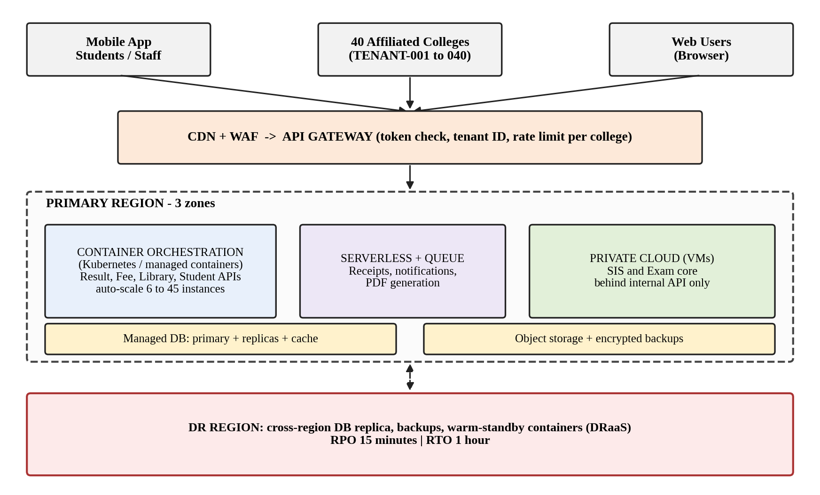
Figure 17: Revised architecture for the Day-4 requirements
Table 33: What changed in the revised design
Area | Original | Revised
Entry layer | Load balancer and WAF. | CDN, WAF and an API gateway with tenant-aware token checks and per-college rate limits.
Application tier | PaaS web instances. | Containers on managed orchestration across 3 zones, auto-scaling from 6 to 45 instances.
Background work | Inside the application. | Queue plus serverless functions for receipts, notifications and reports.
Database | DBaaS primary with standby. | DBaaS with read replicas and a cache for read-heavy lookups; payments always read from the primary.
SIS and Exam core | Directly used by APIs. | Behind an internal API only; read-heavy queries served from replicas or cache, which shields the legacy core.
Availability | Two zones, single region. | Three zones plus a cross-region DR replica with RPO 15 minutes and RTO 1 hour.
Service model mix | IaaS, PaaS, SaaS, DBaaS, DRaaS. | Same mix plus FaaS, MBaaS and managed API gateway; IaaS share reduced to the legacy cores.
Virtualization | VMs for legacy, some containers. | Containers become the default for new services; VMs remain only for SIS and Exam core.

11.4 Evidence-based defence (2 marks)

Capacity calculation
Assumptions (to be measured in a load test): current peak = 200 requests per second; one container instance sustains 100 requests per second; target instance utilisation 70%.
- Target load = 10 × 200 = 2,000 requests per second.
- Instances needed = 2,000 ÷ (100 × 0.70) = 28.6, so 29 instances.
- To survive the loss of one of three zones, the two remaining zones must carry 29 instances, so each zone needs 15 and the maximum is 3 × 15 = 45 instances.
- Baseline for normal days: 2 per zone = 6 instances. Auto-scaling moves between 6 and 45.

Cost comparison for the scalable layer (₹ lakh per year)
Assumptions: the original platform costs ₹0.8 lakh a month at today's load; peak (admissions, results and exams) lasts about 2 months a year; average load without peaks rises to 3× because of the mobile app and colleges.
Table 34: Annual cost: original design scaled statically versus revised design
Item | Original, provisioned for 10× all year | Revised, auto-scaled
Normal months: 10 months × 3 × ₹0.8 | – | 24.0
Peak months: 2 months × 10 × ₹0.8 | – | 16.0
All 12 months at 10 × ₹0.8 | 96.0 | –
API gateway, WAF and CDN (₹0.25 lakh/month) | – | 3.0
Cross-region DR upgrade (₹0.2 lakh/month) | – | 2.4
Monitoring and logging (₹0.1 lakh/month) | – | 1.2
Total | 96.0 | 46.6

The revised design costs ₹49.4 lakh less per year (51.5% lower). Cache and read replicas reduce database load further, but that saving is not counted here.

Security and multi-tenancy
- Tenant identity: each college receives a tenant ID (TENANT-001 to TENANT-040) and its own credentials; the identity service issues a signed token carrying that tenant ID.
- Enforcement: the API gateway validates the token; the service adds the tenant ID to every database query (row-level filtering), so TENANT-007 can never read TENANT-012 records. Fee and payment data is kept in a separate schema with stricter access.
- Fairness: per-tenant rate limits stop one college from consuming shared capacity.
- Protection: TLS everywhere, encryption at rest, payment confirmation on the server side with gateway callbacks, idempotency keys, audit logs and alerts on unusual access.
- Validation: a cross-tenant access test must return access denied before go-live.

Trade-offs
Table 35: Trade-offs of the modified design
Trade-off | Discussion and control
Vendor lock-in | Managed gateway, queue and serverless functions tie parts of the system to one provider. Containers, standard REST and SQL, and portable data exports limit the effect.
Complexity | Containers, queues and multi-tenancy need skilled operation. Use managed orchestration, infrastructure as code and runbooks, and train the staff.
Migration effort | APIs, tenant filtering and replicas need development and testing. Phase the work: API gateway and read APIs first, payments after testing, SIS changes last.
Cost versus availability | Three zones and a DR region add cost, but the ₹46.6 lakh estimate remains less than half of static provisioning.

Validation plan before go-live
- Load test to 10× measured peak and a stress test above it; confirm the 29-instance estimate.
- Zone-failure test (stop one zone) and DR failover test against the RPO and RTO targets.
- Tenant isolation and API security tests, and duplicate and invalid payment tests.
Conclusion of Task 11: Retaining the hybrid foundation and modifying it with an API gateway, container auto-scaling, tenant isolation, three-zone deployment and a stronger DR design meets 10× load and 99.9% availability at under half the cost of provisioning for peak all year. The numbers rest on stated assumptions and must be confirmed by the validation plan above.

